#5 Best Ways To Rank in Google my Business [2019] Latest.
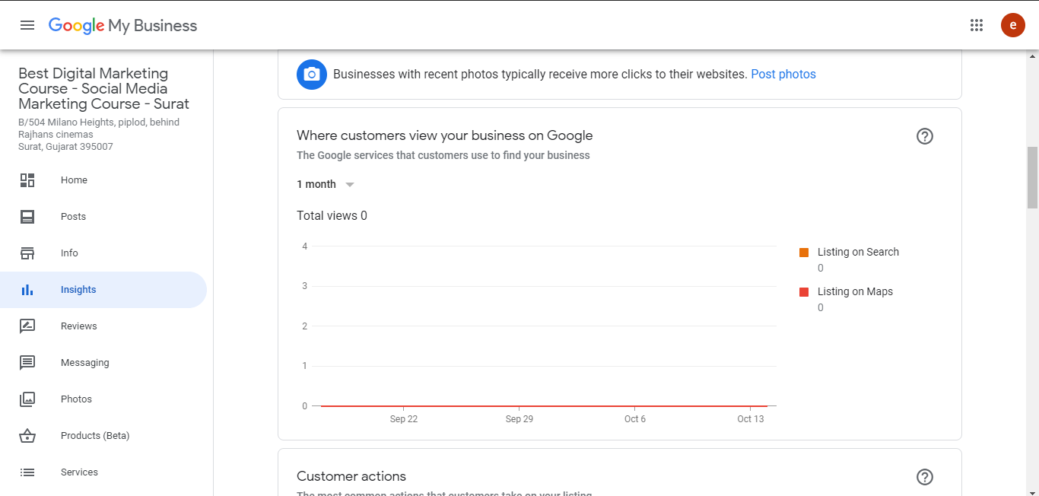
From 0

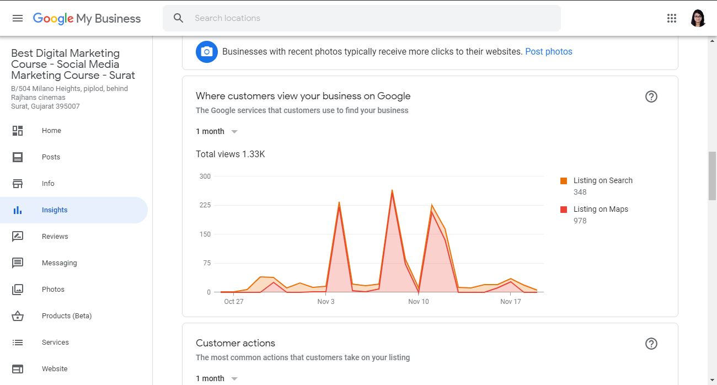
To 1.33K

About Google My Business
Google My Business is a free and easy-to-use tool for businesses and organizations to manage their online presence across Google, including Search and Maps. By verifying and editing your business information, you can both help customers find you and tell them the story of your business.
To give you an easy example, we can say when you search Saloon near me or, you search a particular salon you see a listing, that’s what is called Google my business. The list may look like the follows:
Google my business list

Benefits of using Google My Business

Manage your information

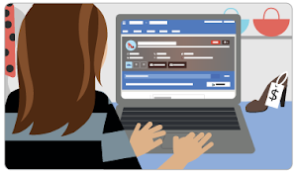
Manage the information that Google users see when they search for your business, or the products and services that you offer. Businesses that verify their information with Google My Business are twice as likely to be considered reputable by consumers.¹ When people find your business on Google Maps and Search, make sure that they have access to information like your hours, website, and street address.

Interact with customers
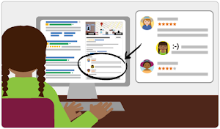
Read and respond to reviews from your customers, and post photos that show off what you do. Businesses that add photos to their listings receive 42% more requests for driving directions on Google Maps and 35% more clicks through to their websites than businesses that don’t.

Understand and expand your presence
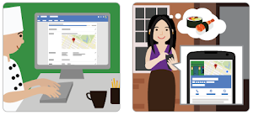
See insights on how customers searched for your business, and where those customers are coming from. You can also see information like how many people called your business directly from the phone number displayed on local search results in Search and Maps. And when you’re ready, seamlessly create and track the performance of Smart campaigns to spread the word about your work.It’s easy to start and free to use.
Content credit: https://support.google.com/business/answer/3038063?hl=en
#5 Ways to Rank Up
- Correct Information:
When you Start Listing your business, Google asks you various information about your business like your name, address, service sector, service area, opening hours, etc. It would be helpful to enter correct and accurate information. Your information should be upto date.
Some small information like:
- Special hours: The timing of your business during holiday or some special days.
- Services: The list of Services that you offer.
- Description: A short detail of your business describing it.
- Short Name: A short name of your business.
- Opening Date: The opening date of your business.
All these information will help you create points.
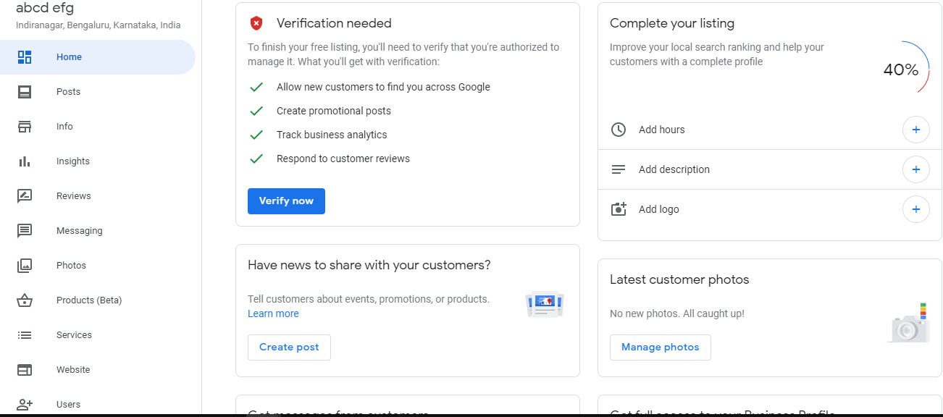
Fill information till it turns 100%
[Google will suggest you what information you should add]
- Posting:
Posting is an option from where you can ad banners and photos to create an event and share post like social media. Google requires you to keep your listing upto date and posting is one of the options to do that. Posting will help you keep you on the top of the listings.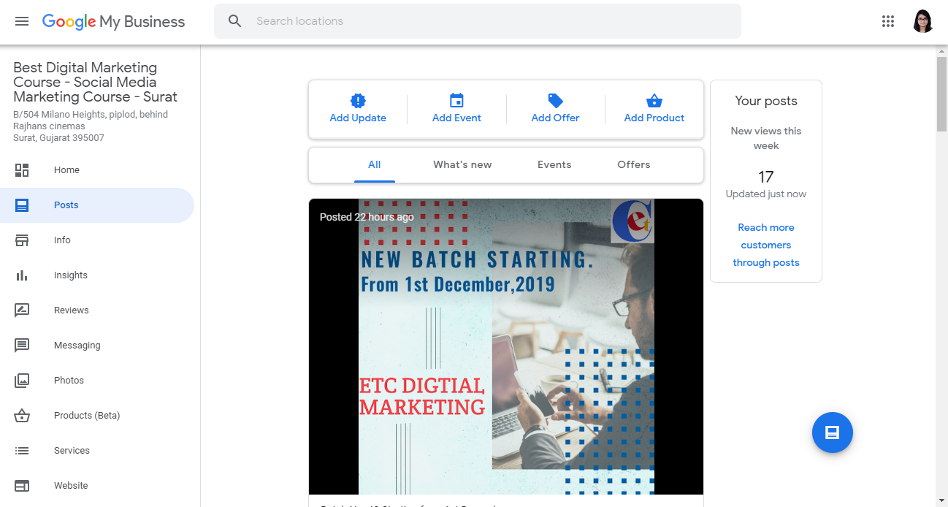
Posting and its options.

- Reviews:
Reviews are a great way to let customers express their thoughts.
Reviews is a type of feedback. The more feedback the better.
Ways to take feedback:
- Asking Customers: Ask your customers to go on the listing and give a review.
- Review Link: Generate review link for your listing and send it to your customer.
One thing that you should also consider is that you should always reply to all the reviews. Whether they are positive or negative the reply should always be positive.
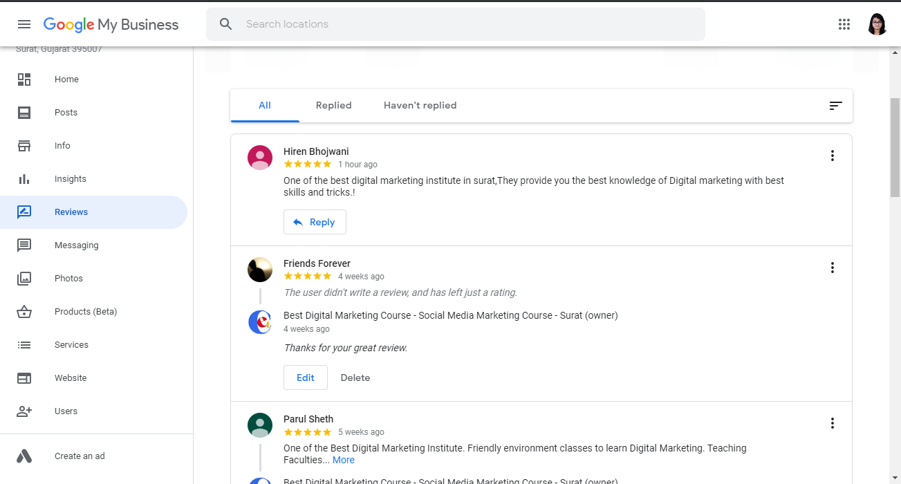
Reviews sections
Reply to the reviews (you can check by clicking on haven’t replied.)
by clicking on haven’t replied.)

- Question & Answers:
Question and answer is a section where anyone can ask you question and anyone can reply to it. It is a very good way to increase traffic. You can add FAQ (Frequently Asked Questions) by yourself and answer it. It is on the front end of the listing so you have to answer it from there. It is recommended that you ask customers to add questions and all those questions are well answered.
Q&A section

- Photos and videos:
Photos and videos section include photos of your location, team, work, logo, cover photo, event photos, etc.
Photos and Videos are a great way to give customers a way to connect to your business, it builds trust.
You should add photos and videos as much as you can, the quality of the photo should be good though it should be as real as possible.
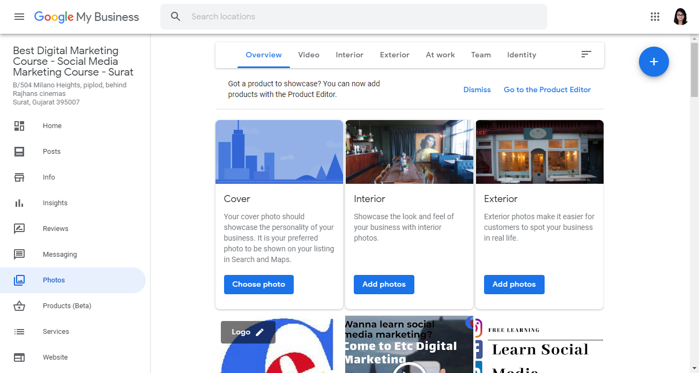
Add Photos and Videos
Bonus: Creating Backlinks
A Bonus Advice, Create backlinks of your business.

